div {

z-index: 1; /* integer */

}The z-index property in CSS controls the vertical stacking order of elements that overlap. As in, which one appears as if it is physically closer to you. z-index only effects elements that have a [position](http://css-tricks.com/almanac/properties/p/position/) value other than static (the default).

Elements can overlap for a variety of reasons, for instance relative positioning has nudged it over something else. Negative [margin](http://css-tricks.com/almanac/properties/m/margin/) has pulled the element over another. Absolutely positioned elements overlap each other. All sorts of reasons.

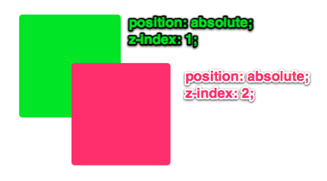

Without any z-index value, elements stack in the order that they appear in the DOM (the lowest one down at the same hierarchy level appears on top). Elements with non-static positioning will always appear on top of elements with default static positioning.

Also note that nesting plays a big role. If an element B sits on top of element A, a child element of element A can **never** be higher than element B.

